Pre Tree Quiz

I. Use the following tree (in original form) for each of the questions below.

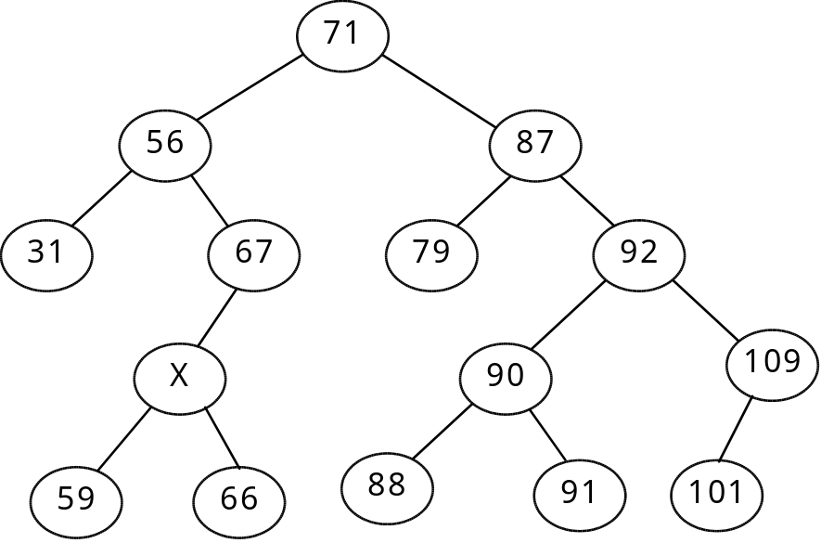

- State the results of a PreOrder Traversal.

71 56 31 67 x 59 66 87 79 92 90 88 91 109 101

- State the results of a PostOrder Traversal.

31 59 66 x 67 56 79 88 91 90 101 109 92 87 71

State the children of 90.  88 91 | Who are the ancestors of 66.  X 67 56 71 | Who are the descendants of 67.  x 59 66
Adding node 99 on what level?  5 | Identify all leaf's in this tree.  31 59 66 79 88 91 101 | What is the height of the tree?  5
What is the width of the tree?  9 | Identify all possible integer values fo x if all values are unique.  60 .. 65 | How many comparisons are need to determine that 89 is not in the tree?  5

On the graph add the nodes containing 45, then 70 and finally 75.

45 is 31 right child 70 is 67 right child 75 is 79 left child

List the output of the trav assuming root points at 71  public void trav(treenode root)  {  if (root != null)  {  trav(root.getRight());  trav(root.getLeft());  System.out.println(root.getValue();  trav(root.getRight());  }  } | 101, 109, 91, 88, 90, 91, 92, 101, 109, 79, 87, 101, 109, 91, 88, 90, 91, 92, 101, 109, 66, 59, x, 66, 67, 31, 56, 66, 59, x, 66, 67, 71, 101, 109, 91, 88, 90, 91, 92, 101, 109, 79, 87, 101, 109, 91, 88, 90, 91, 92, 101, 109

Redraw right subtree of 87 after deleting 92  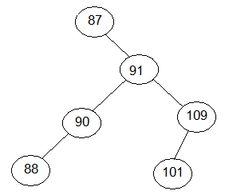 | Redraw right subtree of 56 after deleting 67.  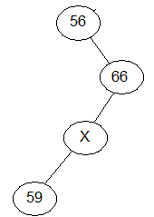
More questions on back!
Evaluate the following expressions

- / * 5 3 % + 20 5 10 = / 15 % 25 10 = / 15 5 = 3

- + % * 7 – 5 1 11 - * 5 8 / 12 2 =
+ % * 7 4 11 - 40 6= + % 28 11 34 = + 6 34 = 40

- 10 6 * 4 / 6 1 + % = 60 4 / 7 % = 15 7 % = 1

- 5 7 2 5 0 ^ + - * 2 4 ^ 5 4 % / - =
5 7 2 1 + - * 16 1 / - = 5 7 3 - * 16 - = 5 4 * 16 - = 20 16 - = 4

Complete the following table by rewriting the given expression
Prefix | infix  (with fewest parenthesis) | Postfix
10 6 * 4 / 7 1 + % | 10 * 6 / 4 % (7 + 1) | 10 6 * 4 / 7 1 + %
+ + 5 6 – 9 % + ^ 7 2 1 3 | 5+6+9-(7^2+1)%3 | 5 6 * 9 7 2 ^ 1 + 3 % - +
/ * 5 3 % + 20 4 10 | 5 * 3 / (20 + 4) % 10 | 5 3 * 20 4 + 10 % /
+ * ^ 4 ^ 3 – 2 + 1 1 5 6 | 4^3^(2-(1+1))+5+6 | 4 3 2 1 1 + - ^ ^ 5 * 6 +
/ * 2 + 4 3 - 9 % 5 3 | 2*(4+3)/(9-5%3) | 2 4 3 + * 9 5 3 % - /
^ % + 8 9 – 7 2 * / 4 1 3 | (8+9)%(7-2)^(4/2*3) | 8 9 + 7 2 - % 4 1 / 3 * ^

